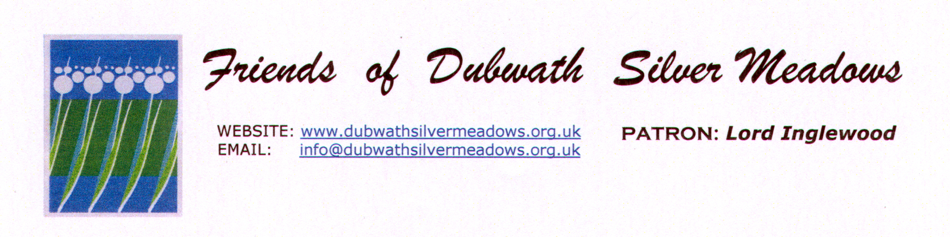

WEBSITE: www.dubwathsilvermeadows.org.uk

EMAIL: dubwathsilvermeadows@gmail.com

Welcome to Dubwath Silver Meadows. If you would like to help to maintain this unique wetland and provide food for the birds you can join us as a ‘Friend’ by donating a minimum of £5 per family per annum. If you do wish to join us please complete the information requested below and return the form together with a cheque made payable to The Friends of Dubwath Silver Meadows to:

Mrs Barbara Petecka
Brydon Ghyll, Bassenthwaite Lake, Cockermouth, CA13 9YD

Or why not set up a regular donation direct to:
TTs Friends of Dubwath Silver Meadows;
Cumberland Building Society
Sort Code 16-52-21; Account no. 51612857.
Please could you put your name as reference, so we’ll know who it’s from.

More information can be obtained via our website or at the email address above.

I would like to join you as a Friend, Volunteer or make a donation.
(Please delete as appropriate)

Name:........................................................................................................

Address:.......................................................................................................

……………………………………………………………………………………

Email:...........................................................................................................

Telephone:...................................................................................................

Many thanks
Barbara Petecka, Secretary, Friends of Dubwath Silver Meadows

Your personal data will be kept in compliance with the new General Data Protection Regulation (GDPR). Please note this information will not be shared with any outside agencies. We will only use your data for administration purposes and to contact you with notices relevant to Dubwath Silver Meadows.

